**A-ARMS CONCEPTION AND MANUFACTURING**

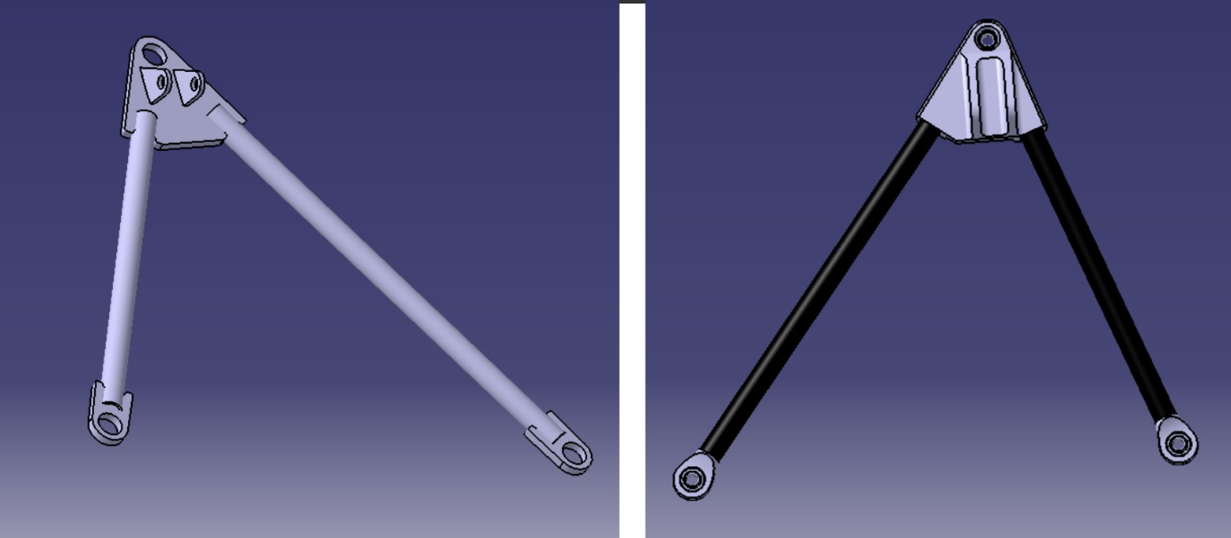

Figure 1: 2 solutions: steel design (left) carbon design (right)

|  |  |  |
| --- | --- | --- |
| **Design** | **Steel design** | **Carbon design** |
| **Mass** | 6 Kg | 3 Kg |
| **Cost estimation (based on cost report)** | 600 $ | 900 $ |
| **Main advantage** | Reliable | Light |

# Gluing specifications

|  |  |
| --- | --- |
| **Gluing surface** | 1,70E-03 |
| **Theoretical maximum shear stress of epoxy structural adhesive used (from datasheet, for a contact between two plates)** | 30.2 MPa |
| **Worst load case (obtained with MecaMaster)** | 5,12 kN |
| **Minimal tensile strength to reach for our process (with a security coefficient of 3)** | 15 kN |

# Test

## 

Figure 2: Test tube

## 

Figure 3: Test tube before and after traction test

Figure 4: Test results of 2 different processes for the sanding operation : with a Dremel (P1) or manually (P2)

# Process flow

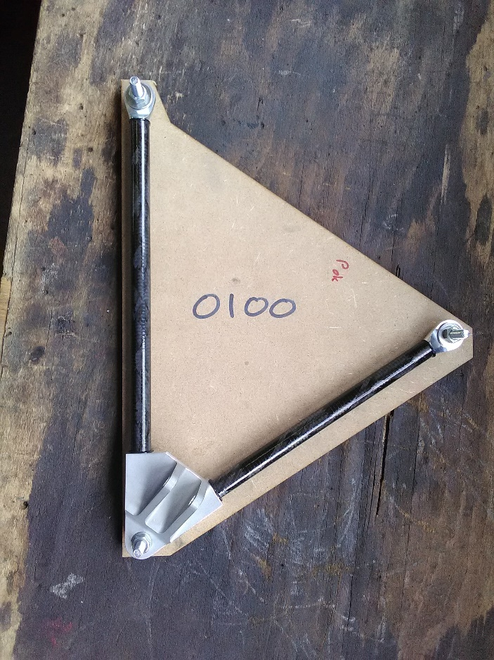

Figure 5: A-Arms on is mounting template

**Step 1: sanding**

* Sanding of the aluminium parts with sandpaper P180
* Sanding of the carbon tubes with sandpaper P180
  + 3 times on a length of 30 mm
  + Visual control

**Step 2: cleaning with acetone**

* 2 times for aluminium parts and carbon tubes
* Let evaporate after

**Step 3: Gluing**

* Application of the epoxy structural adhesive on the inserts

parts all along the surface

* Insert it by turning
* Place it on the template

**Step 4: Drying**

* Let it dry for 7 days

# Verification of current A-Arms

## 

Figure 6: Left to right: Tie rod, front lower left A-Arm and front upper left A-Arm

# Traction log

Figure 7: Example of traction curve during firsts test

Figure 8: Example of traction curve for A-Arms on car